Church of the Nazarene
2016

What The Bible Says About Sleep
  - Young adults

Although sleep seems like an unnecessary daily ritual you have to go through, it actually does the you good, recharging your mind and your body especially after a highly stressful day. Without it, you wouldn’t be able to take on the next day quite as well.
Maybe you do know that you need sleep, but sleep doesn’t come easily. Your mind goes into overdrive and a billion thoughts attack your brain. How much do you owe on that credit card. Your mom is not doing well. There’s a weird pain in your knee that might be serious. Whatever it is, it’s keeping you awake.
“It is useless for you to work so hard from early morning until late at night, anxiously working for food to eat; for God gives rest to his loved ones.” – Psalm 127:2
In this psalm, God is telling you to let the things that bother you lie and rest with you while we sleep, because the solution to your problems will become clearer in the morning when you rise.
Elijah, the Prophet, was so emotionally, physically, and spiritually spent from dealing with false prophets and receiving a death sentence from Queen Jezebel that he ran away.
“’I have had enough, Lord,’ Elijah said. ‘Take my life. I am no better than my ancestors.’ Then he lay down under the tree and fell asleep…All at once an angel touched him and said, ‘Get up and eat.’…He ate and drank and then lay down again.” = 1 King 19:4-6
When you are in crisis, you sometimes want to just get out of there, or self-medicate yourself with alcohol or shopping. Rather, the best thing to do is to take care of your mind and body, which means sleep and eat. Even a short nap is sufficient to recharge your brain.
Although the Bible indicates that sleep is much needed for you to function properly, It also warns against over-sleeping.
“Do not love sleep or you will grow poor; stay awake and you will have food to spare.” – Proverbs 20:13
“I went past the field of the sluggard…the man who lacks judgement…I applied my heart to what I observed and learned a lesson from what I saw. A little sleep, a little slumber, a little folding of he hands to rest – and poverty will come on you like a bandit and scarcity like an armed man.” – Proverbs 24:30-34
These proverbs illustrate that you should sleep in moderation. Too little sleep, and you won’t have enough mental and physical energy to deal with your problems. Too much sleep, and you will live in poverty.
Having problems sleeping? Pray to the Lord before you go to bed.
“David testified, ‘I will both lay me down in peace, and sleep: for thou, Lord, only makest me dwell in safety.’” – Psalm 4:8
Make peace with Him before laying your head down. Confess your sins and commit to His service. Read a couple of verses from the Bible. Just getting God’s word in you should relax you enough for bedtime.
Sleep also comes by easier with a comfortable bed. Investing in a good mattress, pillows, and sheet set will help you fall asleep, and stay asleep. Some of the best mattresses like a memory foam one will improve your sleep drastically, I recommend reading online to make a wise purchase. Allowing you to face whatever tomorrow has to bring.

Honor God By Honoring Your Body
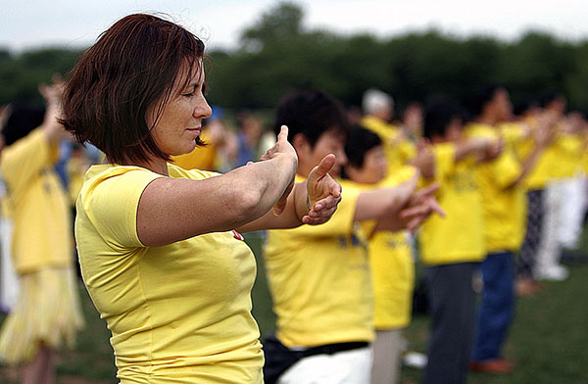
Tim sat on the church pew, as he did most Sunday mornings, and waited for the pastor to commence service. He was a single, middle-aged man, who worked at a car dealership in one of the rich suburbs of Dallas, Texas. Tim was a god-fearing man, who tried to do everything right by the Lord, and so he always listened adeptly to the preacher, later instilling the learned life lessons through practice.
On this particular Sunday, the pastor was intent on making the congregation realize their gluttonous ways and get healthy. Texas is famed for its slogan, “Everything in Texas is bigger.” That included big trucks, big hair, and, unfortunately, big people. His churchgoers were the sort who worked nine to five jobs, ate a bucket of fried chicken for dinner, and stayed home all weekend watching TV. Tim fell into this category of people perfectly.
The pastor talked about taking care of the body physically, so that one has more physical and mental energy for everyday life, to have a better spiritual life and overall quality of life. He discussed how hard it was to fit in a daily exercise and offered the congregation suggestions that might make it easier:
- Exercise in the morning. The mornings are calm and quiet. For most people, after breakfast is a time packed with work and responsibilities. By the end of the day, people are exhausted from the trials and tribulations of the day and just want to relax. Focus on waking up just a bit earlier to have a bit of time for yourself.
- Vary exercise. Doing the same exercise routine over and over again gets quite boring and demotivating. If you are walking 30 minutes a day, simply vary your routine by taking different routes, or making the short drive first to pretty trails in the area.
- Exercise with others. There’s nothing more motivating than being part of a group with the same goals. It’s easier to get out of bed if your friends are ringing your doorbell, encouraging you to join them.
The pastor talked about the body as a house for the spirit and the soul. So if the house is having issues, than the spirit and soul will also have issues. Tim took all of this to heart. One passage in particular from the Bible that the pastor highlighted stood out to him.
“Or do you not know that your body is a temple of the Holy Spirit within you, whom you have from God? You are not your own, for you were bought with a price. So glorify God in your body.” – 1 Corinthians 6:19-20
After church, Tim thanked the pastor for such a moving sermon. On the drive home, Tim was already thinking of ways to change his physical life for the better. He called his good friend from work, John, who often went to a local bar for some beers after work. Tim explained that he wanted to make it a goal to get in better shape, and would John like to join him every morning at the gym before work? John, who was also single, agreed, thinking he might get a better chance at landing a girlfriend if he was more in shape.
From there, Tim and John went to the gym every morning before work, trying out different exercise equipment and talking to some of the personal trainers there about different things they could use at the gym. As Tim and John expanded their knowledge about their local gym, it became quite apparent that they had a favorite piece of machinery: the rowing machine. To get their hearts beating before they engaged in 15 minutes of rowing before going on to other exercise. They would often sit side by side, trying to outdo each other in strokes per minute. Because they were having so much fun, the time flew by, and their 15 minute warm-up session was over. After a month or so, the two friends would go to the gym earlier, so they could spend more time on the rowing machine.
After a few months, Tim was in the best shape of his life, and he was feeling the best he’d had in his life. Instead of staying in all weekend, Tim decided to volunteer his time at a local food bank. He realized that because he was in great physical and mental shape, he didn’t need to take the weekend of for some self-relaxing time. He could spend that time helping others instead, which made him feel that much closer to God. In the end, his pastor was right. Taking care of his body made him have the physical and mental capacity for an enriched spiritual life.

